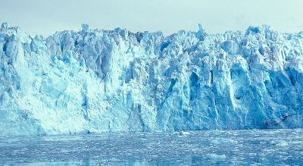

Glacier Introduction

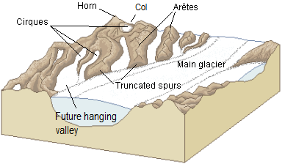

DK Find Out About Glaciers and Quiz Yourself

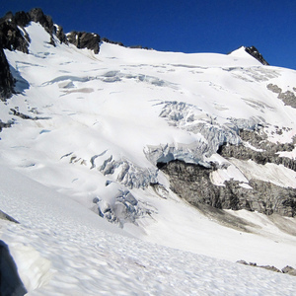
Image licensed under CC BY 2.0

Pollution from Industrial Revolution Melts Glaciers

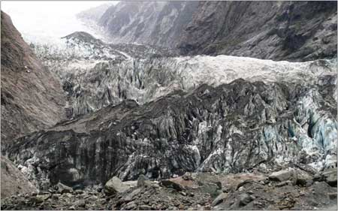

Glacial Ice Shelves, Sediment and More!

GLACIERS

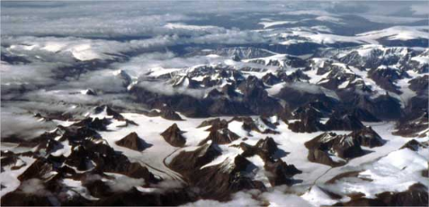

Alpine Glaciers

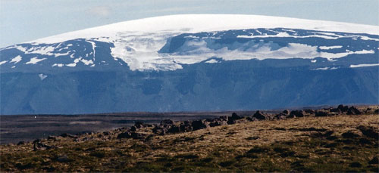

Continental Glaciers

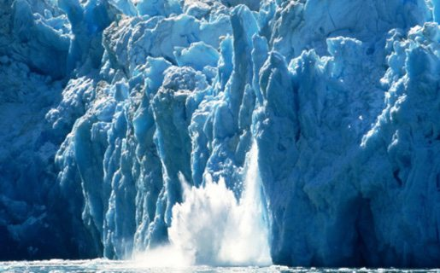

10 Brrr-illiant Glacier Facts

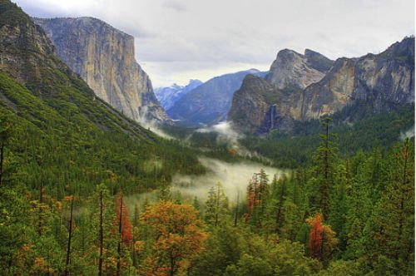

How Glaciers Change the World

NASA Keeps a Close Eye on Glaciers

