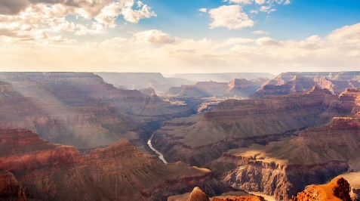
National Geographic's Introduction to Grand Canyon

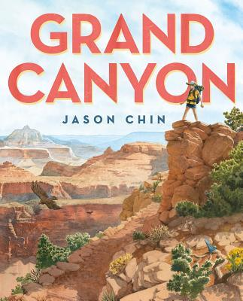
Podcast with Jason Chin author/illustrator of GRAND CANYON

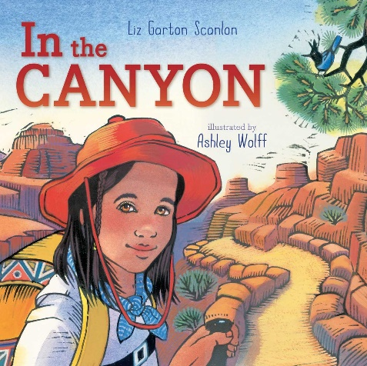
IN THE CANYON by Liz Garton Scanlon Discussion Questions and Crossword Puzzle

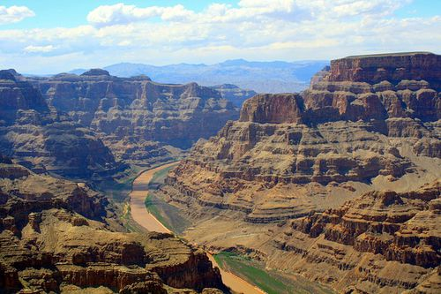
Big News about Old Rocks

GRAND
CANYON

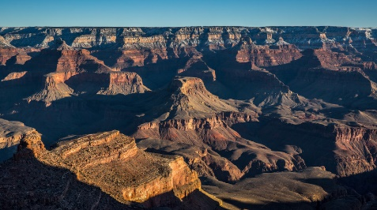

Protect the Grand Canyon

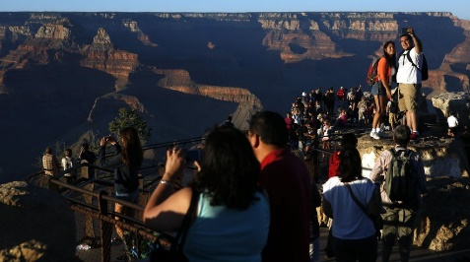
Grand Canyon's Views In Danger

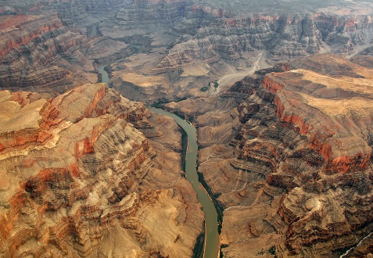

How Deep is the Grand Canyon

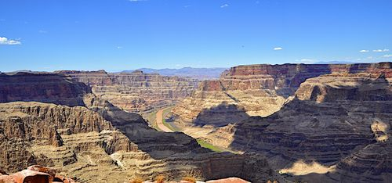

A Grand Old Canyon

