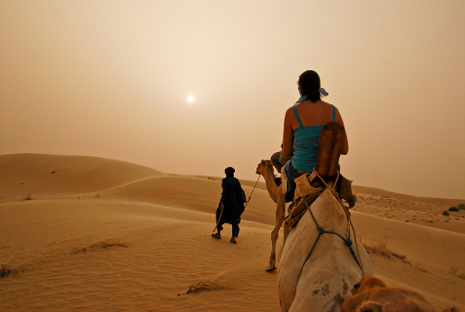

What Causes Sandstorms?

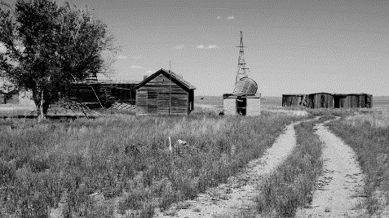

What Was the Dust Bowl?

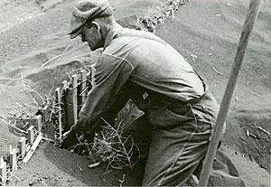

Video Interviews with Dust Bowl Survivors
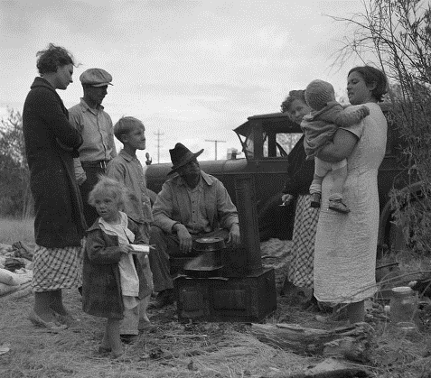

The Dustbowl Timeline

Sandstorms
and
Dust Storms

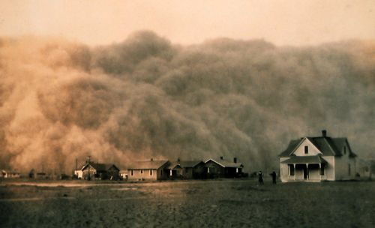

A Time of Dust Storms

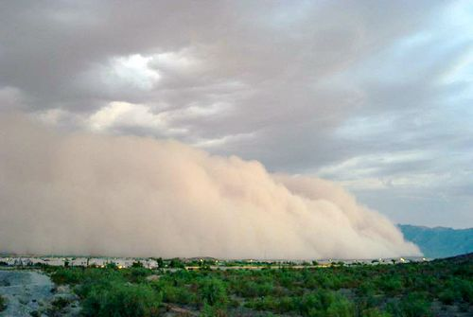

A Dangerous Dust Storm in 2011

Be Ready for Dust Storms

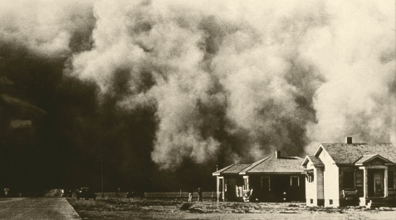

Interview with Dust Bowl Survivor Flora Robertson

