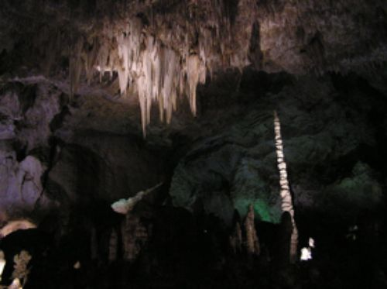

[Inside and Outside Carlsbad Caverns](https://goo.gl/CZgKYS)

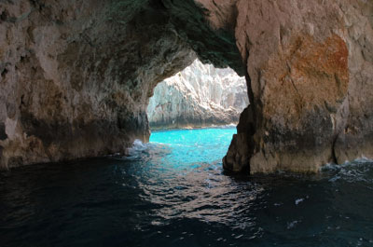

[Find Out About Caves](https://www.dkfindout.com/us/earth/caves/)

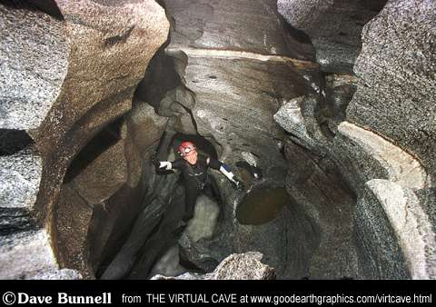

[Different Types of Erosions Make Different Types of Caves](http://www.goodearthgraphics.com/virtcave/erosional_caves/erosional.html)

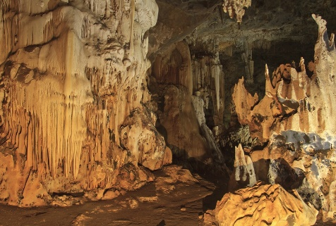

[How Cool Are Caves?](https://wonderopolis.org/wonder/how-cool-are-caves)

CAVES

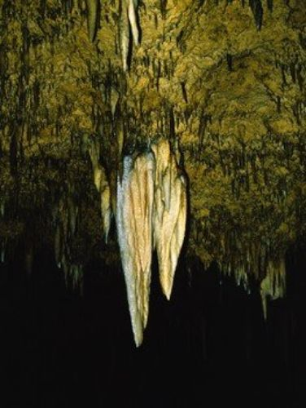

[Creepy Cave Crawlers](https://www.readworks.org/article/Creepy-Cave-Crawlers/18a57170-b9c8-4779-8096-bff69cb61cb5#!articleTab:content/)

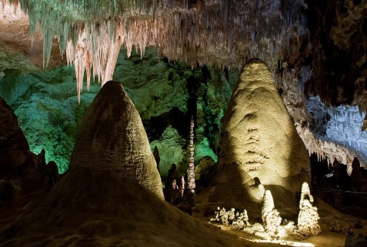

[What Are Speleothems?](https://wonderopolis.org/wonder/what-are-speleothems)

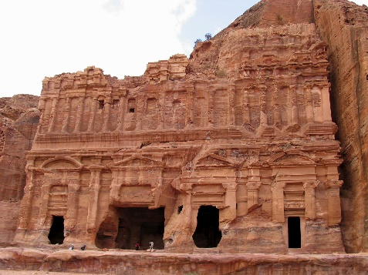

[Can You Carve a City Out of Rock?](https://wonderopolis.org/wonder/can-you-carve-a-city-out-of-rock)

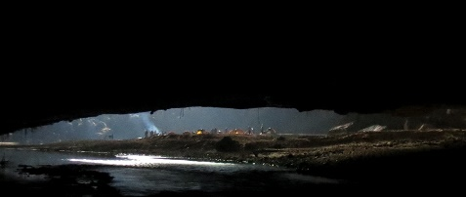

[Where is the World's Largest Cave](https://wonderopolis.org/wonder/where-is-the-worlds-largest-cave)

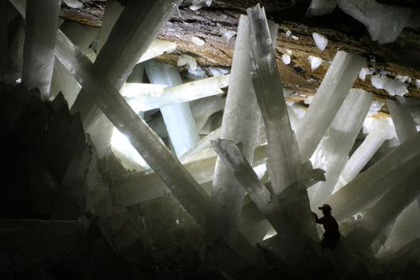

[Water: A Give and Take](https://www.readworks.org/article/Water-A-Give-and-Take/e89ea2fa-8542-406c-9a3f-a0eb3311b7de#!articleTab:content/)