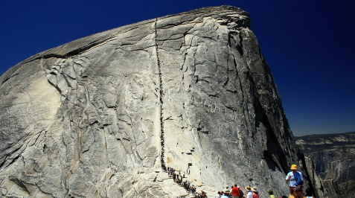

Yosemite's Granite Cliffs Breathe and Heat Can Make Them Fall

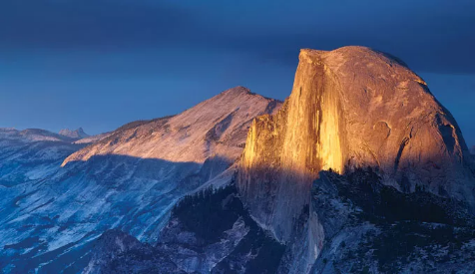

Half Dome-Half Science Half Magic

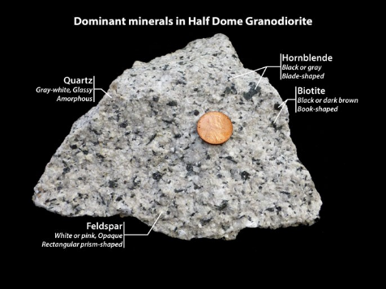

Granite: Plutons, Batholiths and More
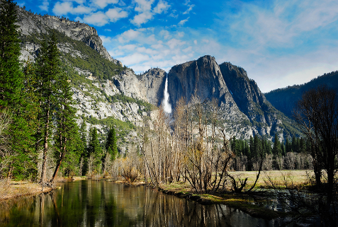

Where is Yosemite?

YOSEMITE

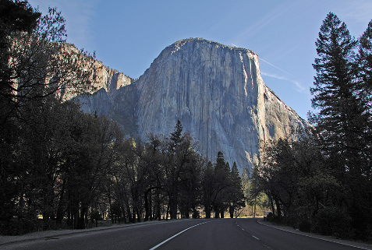

Where Is El Capitan?
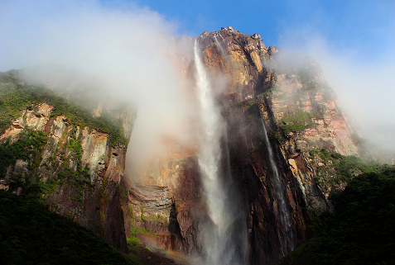

Where Is the Tallest Waterfall

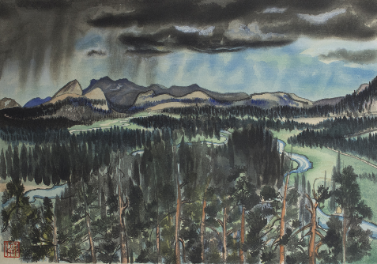

Chiura Obata's Art and Yosemite

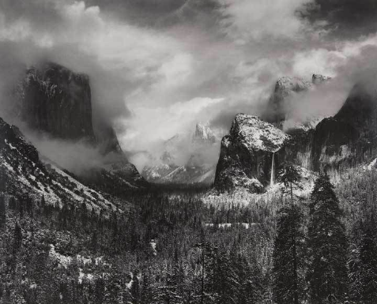

Ansel Adam's Art and Yosemite

